Lion / Lamb Hanging Plate

Materials: 1 paper plate 20 paper strips 13 cotton balls 4 eyes 1 string 1 gluestick
(¼ x 2 ½ in)

Crayons – not included in the bag

1. Place the paper plate with the two holes at the top. Use your crayons to draw a lion face in the
middle on one side of the plate and a lamb face on the other side. Glue the eyes on the faces.

2. For the lion’s mane, put glue on one-half of the back of each paper strip and glue them around the lion’s face. For the lamb’s face, put glue around the edge of the plate and glue on the cotton balls. It works best to put the glue on the plate and add the cotton balls.

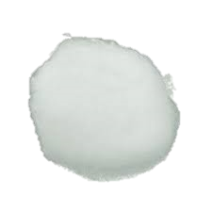

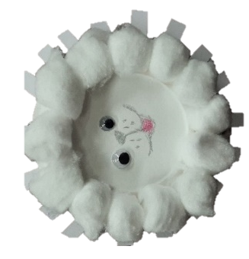
3. Run the string through the two holes in the plate and tie it together to form a loop for hanging your Lion/Lamb plate.
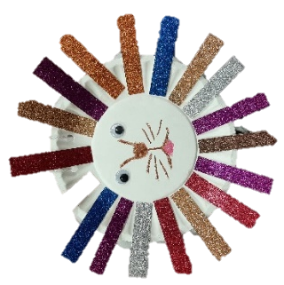

0

